**Title:** Accessibility in Games: Integrating video game accessibility features to lower barriers to access faced by people with disabilities.

**Motivation and Rationale**

**The Context:** Playing video games provide a fun and social form of entertainment. In fact, Gaming is the biggest entertainment industry; it is the most lucrative entertainment industry by far [1]. Statistics published by the German Market and Consumer Database Company, Statista, show that the Gaming Industry is much bigger than the Movie and Music Industry combined. The Gaming Population on the other hand is made up of 2 billion gamers across the world. That is 26% of the world’s population [2]. This means that in every four people, there is at least one person who is a gamer. At the end of 2020, it was established that there are now at least 2.7 billion gamers across the world with a 5.3% growth rate in players year over year. The number of players is expected to keep growing in the foreseeable future and is predicted to rise over 3 billion by 2023 [3].

**The Problem:** According to the World Report on Disability by the World Health Organisation in 2011, a billion people experience some form of disability – 15% of the global population [4]. This 15% rises to 20% among casual gamers who identify themselves as having some form of disability [5] as established by PopCap Games Research. With this taken into consideration, this means that a significant portion of gamers have an impairment which challenges their ability to interface with videogames compared to people without disabilities. Curiously, statistics gathered from the aforementioned survey state that disabled gamers tend to spend more time gamer per week than casual gamers overall. For example, 23% of disabled gamers player more than 16 hours a week compared to 13% of casual gamers overall [6]. This conveys that there are almost twice as many disabled gamers who play more video games, and this indicates that they have more video game engagement than most people. Despite the challenges they face, 94% of disabled gamers continue to play games [7]. With 1 in 5 gamers facing accessibility issues, it is important that this significant portion of the gaming demographic is then addressed properly which is the main inspiration for the Rationale of the project.

**The Rationale and The Proposed Approach:** The main focus for the project is to put more emphasis in accessibility for games. When games are made more accessible, they also become more inclusive, and this encourages more players to buy the game which then enables game developers and publishers to generate more revenue. Of course, more inclusive games also offer a human benefit such that barriers to access will be lowered for those who are facing accessibility issues.

Incorporating accessibility features in games will allow disabled gamers to enjoy the games the way they are meant to be played and experienced. The project will be designed to support the idea that video games can be made more adaptable according to the player’s abilities and simulating less of a handicapped experience. The project will attempt to achieve this by incorporating audio-visual cues to help players who are experiencing certain disabilities such as Visual Impairments or Motor Impairments. More specifically, for people suffering from Colour Vision Deficiency (CVD), otherwise known as colour blindness, the main stimuli (colours) will be replaced with symbols or patterns that the user can associate specific colours with. Another example is for people with Motor Impairments who have trouble playing a game with a traditional controller or mouse and keyboard --- in this case, the point of input (peripherals) will be replaced with voice commands to allow the player to interact with the game hands-free. Consequently, these propositions make the basis for the aims of the project which is to integrate various gaming accessibility features to help facilitate the experience and challenges encountered by players with accessibility issues.

**Aims & Objectives**

**Aim:** To develop a Unity game which incorporates accessibility features to help facilitate the experience and challenges encountered by players with accessibility issues.

**Objectives:**

1. Explore a set of common gaming accessibility barriers including *Visual, Motor, Hearing, and Cognitive Impairments* and investigate established audio-visual techniques that are used to assist players facing such accessibility barriers.
2. Develop separate, individual Unity prototypes or mini-simulations focused on each selected accessibility barrier.
3. Develop a Unity Game that integrates all accessibility techniques from the prototypes into the main game loop.
4. Analyse and evaluate how well the integrated accessibility features satisfy established accessibility guidelines in gaming such as “Game Accessibility Guidelines” and “Includification”
5. Analyse and evaluate the scalability of the integrated accessibility features in terms of its impact on the game’s performance in terms of CPU/GPU Utilisation and FPS.

**Background Research**

|  |  |
| --- | --- |
| **Background Resource** | **Summary and Relevance** |
| 1. PopCap Games research: Publisher's latest survey says that casual games are big with disabled people. [8] | ***Summary****:* A survey of 13,296 gamers with 2,728 (20.5%) among respondents identifying themselves with some form of disability.  ***Relevance****:* This article creates a profile for respondents including those with mild to severe disabilities. Furthermore, the article discusses why disabled gamers continue to play games despite the difficulties. Most importantly, this article shows gaming habits and degree of engagement by disabled gamers compared to most casual gamers. All this information gathered allows the researcher to understand the habits of disabled gamers and why they continue to gravitate towards video games. |
| 1. Games Accessibility Guidelines [9] | ***Summary****:* A living document and the product of a collaborative effort between a group of studios, specialists, and academics to produce a straightforward developer friendly reference for ways to avoid unnecessarily excluding players and ensure that games are just as fun for as wide a range of people as possible [10].  ***Relevance****:* This living document helps in the evaluation of the accessibility techniques incorporated into the main game loop; it goes hand in hand with *Objective 4*. It allows the researcher to evaluate the finished according to three sets of accessibility guidelines: Basic, Intermediate, and Advanced. |
| 1. Includification – A Practical Guide to Game Accessibility by the Able Gamers Foundation [11] | ***Summary****:* Includification is a book published the AbleGamers Foundation in 2012. It is an award-winning, first of its kind, outline on how to make games accessible for players with disabilities. This guide was a huge leap forward for accessibility. It was on the desk of developers at major studios around the world [12].  ***Relevance****:* This book will help guide the researcher/developer to make technical decisions particularly on what type of accessibility features to implement. This book mainly supplements *Objective 2 and 3* where the focus is development and implementation of accessibility techniques. This book also serves as a secondary reference to evaluate the finished product. |
| 1. Designing Universally Accessibly Games by Dimitris Grammenos, Anthony Savidis, Constantine Stephandis [13] | ***Summary****:* This article introduces concepts proactively designed to allow for a universally accessible game that is adaptable to individual gamer characteristic enabling people with diverse abilities to play without need for particular adjustments or modifications  ***Relevance****:* A very comprehensive game tackling multiple accessibility issues quite similar to the project being proposed. The most significant part of this paper is the fact it attempts to use speech-recognition to assist Motor Impaired players which is similar to the proposed approach in this project proposal. This related literature will act as a guide during the implementation stage but more specifically with the Voice Commands implementation. |
| 1. A Study on Accessibility in Games for the Visually Impaired by Imran Khaliq and Isabelle Dela Torre [14] | ***Summary****:* The main focus for this study is to provide more accessibility for the visually impaired. This study explores the current state of technology and design practices to provide techniques categorized in three approaches: visual, audio, and tactile.  ***Relevance****:* This paper discusses the implementation of colour-blind friendly colour schemes where the user is allowed to change colour palettes to suit three types of colour blindness. This technique can potentially be adapted to the proposed projects method to help the Visually Impaired, supplementing the earlier proposed of replacing stimuli by incorporating symbols and patterns to associate with certain colours. |
| 1. An Empirical Study of Issues and Barriers to Mainstream Video Game Accessibility [15] by John R. Porter & Julie A. Kientz | ***Summary****:* This paper presents the findings of a pair of complementary empirical studies intended to understand the current state of game accessibility in a grounded, real-world context and identify issues and barriers [16].  ***Relevance****:* This paper discusses the current of the gaming industry with respect to accessible games allowing the researcher to understand common trends in the gaming industry. Findings mention that while many games leverage assistive technologies (like aim assist), it ultimately diminishes the gameplay experience. The proposed project will attempt to implement accessibility techniques without diluting the overall gameplay experience as mentioned in this related literature. |

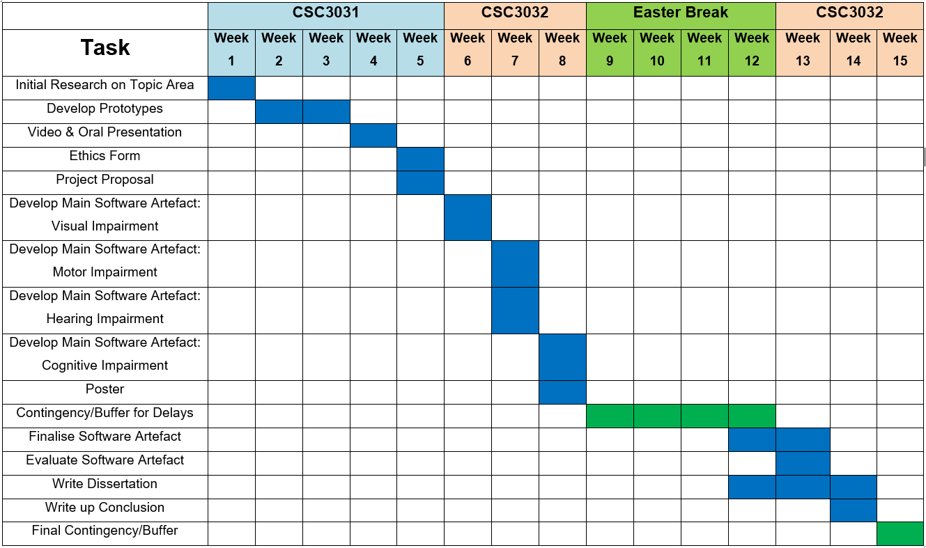**Diagrammatic Workplan**

**Figure 1.0 – Gantt Chart** (Contingency/Buffer Period in Green)

**Brief Explanation of the Workplan**

The figure above shows a Gantt Chart to visualise the schedule for the different stages of the project’s development process. Major stages of the project are separated into two main timeframes which are CSC3031 and CSC3032 with the Easter Break being mostly used as a contingency or buffer period in case of delays in the project implementation.

In summary, initial research was conducted on the topic area for the first week of CSC3031. Initial research includes common accessibility issues and techniques used to facilitate the experience of people facing such issues – this helps achieve *Objective 1*. As part of *Objective 2* Prototypes were then developed for the next 2 weeks to showcase the potential of the project as well as gather supervisor feedback and approval. The next 2 weeks after this were then allocated for completing the Video & Oral Presentation as well as the Ethics Form & Project Proposal respectively. These are the last goals to finish the CSCC3031 module at week 5.

Development for the main software artefact will then be undertaken from week 6 to – with each week focusing on a deliverable based on an accessibility barrier or impairment. In other words, this is the period dedicated to achieving *Objective 3* where the accessibility figures are integrated together into a singular game loop. The next time period fall into the Easter break which starts from week 9 and end on week 12. Although this is intended for an academic break, the researcher has decided to do some occasional dissertation writing as well as starting to finalise the software artefact on week 12 onwards. More importantly, this rest period will be used as a contingency or buffer phase where this free time will be used to catch up on software development work, or other deadlines, as needed. In the final weeks of CSC3032, the researcher aims to polish and refine the software artefact and evaluate the project with respect to established accessibility guidelines as well as its impact on game performance. If the researcher reaches this point, then *Objectives 4 & 5* would have been achieved where it is mainly concerned with evaluating the finished product. The dissertation will also be written up and have the conclusion finalised at this point just before the last week of CSC3032. To end, the last week of CSC3032 will be reserved as another contingency or buffer period as similarly observed in the Easter Break just in case the researcher falls behind targets.

Throughout the development process, risks can also arise. The first potential risk that could derail project development is hardware/device damage. Currently speaking, the project is intended to be developed using the researcher’s personal laptop. In the event that this device gets damaged, for whatever reason, it is important to have a backup plan so as not to hinder progress. To mitigate the impact of such an event happening, University computer clusters will be used as an alternative development device. Another risk to progress is storage being compromised. However, this should have minimal impact as the project is intended to be continually backed up using cloud storage such as Microsoft OneDrive or Google Drive. Finally, the most important risk to project development is when the researcher fails to meet targets on time and falls behind schedule. As previously mentioned, the Easter Break will be used as a buffer period along with the final week of CSC3032 to finish any tasks that are falling behind schedule.

**References**

[1] F. Richter, "*Gaming: The Most Lucrative Entertainment Industry By Far*", Statista, Sept. 22, 2020. [Online]. Available: https://www.statista.com/chart/22392/global-revenue-of-selected-entertainment-industry-sectors/. [Accessed: 03- Mar- 2022].

[2] A. Beattie, “*How the Video Game Industry Is Changing*” Investopedia, Oct. 31, 2021. [Online]. Available: https://www.investopedia.com/articles/investing/053115/how-video-game-industry-changing.asp. [Accessed: 23- Feb- 2022]

[3] T. Wijman, "*Three Billion Players by 2023: Engagement and Revenues Continue to Thrive Across the Global Games Market | Newzoo*", Newzoo, Jun. 25, 2022. [Online]. Available: https://newzoo.com/insights/articles/games-market-engagement-revenues-trends-2020-2023-gaming-report/. [Accessed: 03- Mar- 2022].

[4] World Health Organisation, “*World Report on Disability*”, World Health Organisation, 2011. [Online]. Available: https://www.who.int/disabilities/world_report/2011/report.pdf [Accessed: Feb- 23- 2022]

[5], [6], [7], [8] Games Industry International, “*PopCap Games research: Publisher's latest survey says that casual games are big with disabled people*.” Games Industry, Jun. 11, 2008. [Online]. Available: https://www.gamesindustry.biz/articles/popcap-games-research-publisher-s-latest-survey-says-that-casual-games-are-big-with-disabled-people

[9], [10] Games Accessibility Guidelines, "*Game accessibility guidelines | A straightforward reference for inclusive game design*", Gameaccessibilityguidelines.com, 2022. [Online]. Available: https://gameaccessibilityguidelines.com/. [Accessed: 03- Mar- 2022].

[11], [12] Includification – A Practical Guide to Game Accessibility by the Able Gamers Foundation", Accessible Games, 2022. [Online]. Available: https://accessible.games/includification/. [Accessed: 03- Mar- 2022].

[13] D. Grammenos, A. Savidis and C. Stephanidis, "*Designing universally accessible games*", Computers in Entertainment, vol. 7, no. 1, pp. 1-29, 2009. Available: https://dl.acm.org/doi/pdf/10.1145/1486508.1486516. [Accessed 3 March 2022].

[14] I. Khaliq and I. Torre, "*A Study on Accessibility in Games for the Visually Impaired*", Proceedings of the 5th EAI International Conference on Smart Objects and Technologies for Social Good, 2019. Available: https://dl.acm.org/doi/pdf/10.1145/3342428.3342682. [Accessed 3 March 2022].

[15], [16] J. Porter and J. Kientz, "*An empirical study of issues and barriers to mainstream video game accessibility*", Proceedings of the 15th International ACM SIGACCESS Conference on Computers and Accessibility, 2013. Available: https://dl.acm.org/doi/10.1145/2513383.2513444. [Accessed 3 March 2022].